**CHAPTER ONE**

**INTRODUCTION**

This chapter describes the project and provides some background information. Furthermore, this chapter follows the project's problem description to provide a clear understanding of the project's scope and objectives. This chapter will serve as a blueprint for all subsequent stages of development.

**1.1 Background of the Study**

Birth Registration is a fundamental right of all children and a basic function of all modern governments. Promoting children’s right to birth registration falls clearly within UNICEF’s mandate. Birth Registration comprises two elements: entering details of a child’s birth into official government records, and issuing a birth certificate to the child’s parents, including information on the parents’ names, dates, and places of birth and further information such as nationality. There has been some progress, though small in raising birth registration levels.

Although birth registration is almost complete in all developed countries, the lack of progress on civil registration in many developing countries means that global inequalities in birth registration are now extreme. The births of approximately 230 million children under the age of 5 have not been registered. Of these, around 85 million are in sub-Saharan Africa, 135 million in Asia (east and south Asia and the Pacific), and the remainder in the rest of the world. Birth registration may also be vital for confirmation of nationality following tumultuous events such as armed conflict and situations of state succession. The registration of births and acquisition of citizenship are distinct processes; however, birth registration serves as important proof of the facts that form the basis for the conferral of citizenship at birth. More specifically it establishes a legal record of where the child was born and who his or her parents are and thus whether the child can acquire citizenship based on place of birth or descent. Children who are not registered are excluded from the benefits of citizenship in ways that vary between countries. A birth certificate may be required to obtain access to basic services such as health and education, and it can also help to protect children from situations of exploitation and violence, such as child marriage and child labor, and achieve convictions against those who have abused a child (Sonali, 2021).

The conventional method of birth registration is by human inspection. Manual birth registration is complex and impractical for a large increase in population. The cost of registering a child, loss of registration certificate by the parent and child, and inaccurate population statistics are possible problems that inaccurate birth registration records can cause. Birth registration became an issue of utmost importance as a result of difficulties encountered while obtaining accurate population statistics essential in social services planning for any government and in ensuring that adequate resources and budgets are made available to address the needs of the populace. The use of a globally accessible device for birth registration has shown great potential in this field. The performance of the Online National Database for Birth Registration was evaluated in terms of accessibility, speed, cost, and capacity; and the result confirmed that the proposed Online National Database for Birth Registration will be able to assist government officials in terms of having a globally accessible system, speeding up the birth registration process, reducing the cost of registering a child and capable of keeping registration details for future use (Sonali, 2021).

**1.2** **Statement of the Problem**

The manual method of birth registration is by human inspection which is prone to so many errors. The cost of registering a child, loss of registration certificate by the parent and child, and inaccurate population statistics are possible problems that inaccurate birth registration records can cause. The use of the globally accessible device for birth registration has shown great potential in this field. The performance of the Online National Database for Birth Registration was evaluated in terms of accessibility, speed, cost, and capacity; and the result confirmed that the proposed central e-Birth registration and certificate issuing system will be able to assist government officials in terms of having a globally accessible system, speeding up the birth registration process, reducing the cost of registering a child and capable of keeping registration details for future use.

**1.3 Aim and Objectives of the Study**

The research work aims to develop a Central E-Birth Registration and Certificate Issuing System. The objectives are to:

1. Develop a system for easy registration of Birth Certificates and to enable printing of the hard copy of the Birth Certificate.
2. Design a user-friendly application that can easily verify certificates without wasting much time going to the place for Birth Certification.
3. Develop the application using HTML, CSS, JavaScript, and Django (Python).

**1.4 Scope of the Study**

This research work focuses on the development of a Central e-Birth Registration and Certificate Issuing System, for newly born babies. The system will not cover the registration of adults, the thesis does not go beyond this.

**1.5 Limitations of the Study**

This study's scope has been constrained by several issues, including that the system will be only on a local host as the web application is designed for an undergraduate program, it is also limited by:

**Time** - The time allowed for research for this study was severely constrained due to the researcher's active academic pursuits.

**Finance** - The requirement for a typical functional personal computer unit to execute and debug the application software hampered the task's quick and simple progress.

**1.6 Significance of the Study**

The main importance of this study is that it helps in the provision of an easy way of registering and obtaining Birth Certificates anywhere and at any time.

**1.7 Project Organization**

For ease of study and proper understanding of this project write-up, it is planned and organized into five chapters. The description of what each chapter contains is explained below:

**Chapter One: Introduction**

Chapter one contains an introduction to the whole write-up, the problem of the study, the aims and objectives of the study, the significance of the study, the scope and limitation of the study, and the organization of the report.

**Chapter Two: Literature review**

This chapter contains the literature review of the study, an overview of the proposed system, and the contribution of other scholars on the subject matter being discussed.

**Chapter Three: Methodology and Design**

This chapter is concerned with the presentation of the results of system analysis and design. It presents the research methodology used in the development of the system to facilitate an understanding and effective future implementation of the system.

**Chapter Four: System Implementation Evaluation**

The Chapter contains system design implementation and documentation, design of the system, output design, input design, and system requirements for implementation.

**Chapter Five: Summary, Conclusion, and** **Recommendation**

The chapter provides a summary of major findings, conclusions, and recommendations based on the study conducted.

**1.8 Definition of Terms**

1. **Database**: A database is a system intended to easily organize, store, and retrieve large amounts of data. It consists of an organized collection of data for one or more uses, typically in digital form.
2. **Issuance**: the act of supplying an official document, in this context a birth certificate.
3. **Registration**: the act of making an official record of a person’s information
4. **System**: whole compounded of several parts or members, system", literary "composition". Is a set of interacting or interdependent system components forming an integrated whole.
5. **Information**: processed data.
6. **Website:** also written as web site, collection of related web pages, including multimedia content, typically identified with a common domain name, and published on at least one web server.
7. **Hypertext Markup Language (HTML):** HTML (Hypertext Markup Language) is a text-based approach to describing how content contained within an HTML file is structured. This markup tells a web browser how to display the text, images, and other forms of multimedia on a webpage.

**CHAPTER TWO**

**LITERATURE REVIEW**

**2.1 Introduction**

This chapter aims to explain how the topic under research relates to prior research, current practice, or other areas of knowledge by mentioning relevant works by other scholars that have dealt with a related issue. Furthermore, this chapter will present a synthesis of the current research on the issue, highlighting areas of agreement, disagreement, and gaps in the literature, to show the relevance of the project topic in the field and to recommend opportunities for future study.

**2.2 Literature Review**

Oliha et al. (2019). An Electronic Birth Record Management System for Nigeria

Nigeria currently has a centralized Civil Registration and Vital Statistics (CRVS) system with no effective ways of detecting fake birth certificates or contradicting birth records. Due to a large number of birth registration centers with varied certificate looks, textures, and signatures, detecting counterfeit birth certificates or contradicting birth records in Nigeria is now very impossible. The unpleasant consequence of such a birth registration system is the dependence on erroneous data for national resource allocation, planning, and immigration control. This highlights the importance of an electronic birth record management system in Nigeria.

The Sublime Text Integrated Development Environment (IDE) was used in the development of the prototype civil system - a text development environment for creating script files such as PHP and markup files such as HTML. To make the system more appealing, Bootstrap was utilized as a foundation for creating a CSS/HTML layout library, while JavaScript was used to create the system's interactive interface and form validation.XAMPP (Cross-Platform (X), Apache (A), MySQL (M), PHP (P), and Perl (P)) was used as a local server to test the system using a structured query language and MySQL for database administration.

Season Affective Disorder (SAD) research approach was used. The following were the results of the interviews:

1. Individual birth information verification (retrieval) is grossly inefficient, unreliable, and expensive.
2. No means of checking duplicate birth registration/records of individuals.
3. Birth records were prone to alteration, theft, destruction, or disappearance.
4. Birth registration and record maintenance are manual.
5. Third parties (e.g., schools, hospitals, immigration agents, etc.) do not have direct access to birth information;

This study revealed the shortcomings of Nigeria's current civil birth registration and record management system. It created a working prototype of an electronic birth record management system. The system enables fast verification of Nigerians’ birth records and is capable of detecting problems such as birth information tampering, theft, destruction, duplication, and fabrication. When fully implemented, this method will thereby reduce birth information fabrication in Nigeria.

Ojokoh and Afolayan. (2017). E-birth Registration and Certificate Issuance System.

During the course of this research, it was learned through oral interviews with birth registrars in the NPC office of Akure South Local Government, Ondo State, Nigeria, that birth certificate collations and registrations were done manually, and that gathering information about the registrant is stressful due to the large collection of files. The above limitations have necessitated the development of a web-enabled registration and issuance system.

Over time, several software development strategies, approaches, models, and techniques have been used to create the software (both generic and customized). The system in this study is built on a three-tier design.

1. The back end, which is controlled by the MySQL Database Management System, holds all non-visible information on the website.
2. The middle end is defined by web servers such as Apache Web Server, MySQL DBMS, and PHP (WAMP) server.
3. The front end is comprised of HTML (HyperText Markup Language), CSS (Cascading Style Sheet), JQuery, and Java Scripts.

The establishment of an e-birth certificate issuing system will allow applicants to register for their birth without having to travel to a specific zone or location and to obtain the certificate immediately over the internet. It will also provide another channel for the nation to generate a citizen population without the need for another census program since monthly data gathering can be simply done and acquired successfully and efficiently.

The system was evaluated using data that was readily available. However, the system's security will be evaluated as a future study issue.

Sonali (2021). Online Birth Registration & Certification System.

The conventional technique of birth registration is human examination. Manual birth registration is complicated and inefficient in the face of rapid population growth. The expense of registering a child, the loss of the registration certificate by the parent and child, and erroneous population numbers are all potential consequences of inaccurate birth registration data. Birth registration became an urgent issue as a result of the difficulties encountered in obtaining accurate population statistics, which are essential in any government's social service planning and in ensuring that adequate resources and budgets are made available to address the needs of the populace.

The current system was built using Microsoft Visual Studio, which is used to develop computer programs for Microsoft Windows as well as web pages, online applications, and web services. Furthermore, in the system, we employed MySQL, a structured query language for data storage, and XAMPP, one of the most frequently used cross-platform web servers, which allows developers to construct and test their applications on a local webserver. PHP, a server-side scripting language, is the back-end language for creating the interface we picked. For the user interface, HTML, JavaScript, AJAX, and JQUERY are used. Because this project is a method ofproblem-solving and meeting requirements that has a good and long-term influence.

Birth registration and subsequent certificate issuing not only promotes human rights to citizenship, but also to good health, education, social security, and general human development. As a result, timely child registration should be pushed as a right problem. This study discovered that a high level of birth registration was associated with a high degree of birth registration awareness among the urban population. However, the results of this study appear to indicate that it is more of a benefit for children whose parents are educated, rich and reside in cities.

Khandagale, et al. (2022). Web Base Online Birth Registration and Certification System

The goal of this suggested endeavour is to provide a remedy to the existing situation with birth registration. To address the issues and challenges that residents have while registering their births and negotiating with government officials here and there for the certificate. As a result, the person may obtain the certificate quickly and simply, saving both himself and the government time. This encourages more effective and can be readily taken utilizing the online system and effective data collection, storage becomes easy and administration of paper certificate becomes easy and we can acquire it online.

Over time, additional software development processes, approaches, models, and techniques were used to create the software (both generic and customized). The system in this study is built on a three-tier design, with MySQL serving as the backend. The middle end is identified by web servers such as Apache, MySQL, and PHP (WAMP), whereas the front end is implemented using HTML (HyperText Markup Language), CSS (Cascading Style Sheet), JQuery, and Java Scripts.

The proposed system encourages more efficient data collecting, simplifies storage, and allows for online credential maintenance. This initiative would also provide funds for national planning by monitoring the growth or decline in the birth rate, and we would be able to prepare for the young based on these citizens. Population forecasting may be done by running reports from the system and designing charts to gain rapid insights.

Oshomoh. (2017). Design and Implementation of an Online National Databasefor Birth and Death Registration (A Case Study of NationalPopulation Commission, Benin City).

The current system was found to employ a manual approach for birth and death registration. The information is gathered on an A4 sheet of paper divided into five areas. Each part comprises information on the child, mother, father, informant, and registrar. The obtained data is subsequently forwarded monthly to the National Population Commission (NPC) headquarters. This necessitates significant resources at the state level in terms of employees, equipment, and storage space for these records. As a result, birth and death registration in Nigeria is still manual. This procedure has various downsides, including delays in data transfer from the location of birth or death to the NPC, keying mistakes, data duplications, and inconsistencies.

The system includes a user-friendly interface that makes it simple for all users to utilize. The client-side will be developed in HTML (Hyper Text Mark-Up Language) and accessed using a web browser, whilst the middleware program will be implemented in PHP (Hypertext Pre-processor), a sophisticated computer language used to create dynamic and interactive Web sites. PHP is a programming language that runs on a server. PHP was chosen because of its simplicity of connection and manipulation with several databases. MySQL will also be utilized to assist decrease data redundancy and regulate security by establishing permission levels where only defined users may add, remove, and update data.

The advantages of adopting an online database for birth and death registration cannot be overstated. This is because the technology will speed up the production of birth and death certificates, improve registration correctness, eliminate incidents of misplaced individual files, and decrease paper pileups in offices.

Pelumi. (2016). Development of a Web Application for Birth and Death Certificate Request.

As a result of the difficulties encountered in obtaining accurate population statistics, which are essential in social service planning for any government, and in ensuring that adequate resources and budgets are made available to address the needs of the population, childbirth and death registration became an issue of paramount importance. Access to civil registry services is difficult, as is the expense of registering a birth or death, as are great distances to registration centres, and the loss of a registration certificate. Furthermore, many people do not prioritize child-birth and death registration because they are preoccupied with a variety of other everyday issues.

The study is conducted via the internet and journals. The waterfall approach will be used for this project's requirements analysis, design, implementation, testing, integration, and maintenance. The system's functionality is represented by the Use Case, Data Flow Diagram, Entity-Relational Diagram, and Entity-Relationship Diagram. PHP, Bootstrap web template, MySQLi, Xammp Server, and Notepad++ will be used to implement the project. PHP was utilized in the software development since it supports relational DBMS features such as file manipulation and relational capability.

This project was undertaken due to the need for citizens to apply for birth and death certificates, which allows the National Population Commission to keep track of citizens' birth and death records, resulting in the development of a web-based application that allows citizens to apply for birth or death certificates, pay online, and receive the certificate in pdf format.

**2.3 Summary of Related Literature Reviews**

|  |  |  |
| --- | --- | --- |
| **Author &Year** | **Title & Description** | **Merit and Demerits** |
| Oliha et al. (2019). | An Electronic Birth Record Management System for Nigeria  This paper developed an electronic birth registration system to manage birth records throughout many registration centers in Nigeria. | Any  birth information can be checked to checkmate  falsification irrespective of its registration center.  The proposed system is yet to be deployed. |
| Ojokoh and Afolayan. (2017). | E-birth Registration and Certificate Issuance System.  This study presents a web-based birth registration and certificate issuing platform that will aid government authorities in terms of speeding up the child-birth registration procedure, lowering the cost of registering a kid, and storing registration records for future use. | The system aided in keeping track of the nation's population in terms of gender, children, and adults.  The system might possess security issues as was suggested for future research. |
| Sonali (2021). | Online Birth Registration & Certification System.  The proposed web-based birth certificate system results in an easily and internationally accessible system, which speeds up the birth certificate issuance procedure. | The system minimized paperwork for birth applications.  An Internet connection is a must. Lack of network can create problems |
| Khandagale, et al. (2022). | Web Base Online Birth Registration and Certification System.  The system provides a simple method to register and acquire a birth certificate from anywhere and at any time. | This initiative would also provide funds for national planning  The system is a privilege for children whose parents are educated and elite. |
| Oshomoh (2017). | Design and Implementation of an Online National Databasefor Birth and Death Registration.  The system tends to provide solutions to present challenges in birth and death registration, promoting a more effective and efficient data gathering, storage, processing, and retrieval approach. | Data consistency and data security were achieved.  Deep technical know-how is needed to operate the system. |
| Pelumi (2016). | Development of a Web Application for Birth and Death Certificate Request.  The project is intended to create a website where citizens can request birth and death certificates. | The system provided improved efficiency in obtaining certificates in a digital format.  The system was not deployed to maximize its efficiency. |

**2.4 Analysis of the Current System**

The current system of manual system of birth registration and issuance involves a process in which the information about a person's birth is recorded and a physical document, such as a birth certificate, is issued to prove their identity and age. This system is often used in countries or regions where there is a lack of access to electronic databases or advanced technology.

There are several potential advantages to using a manual system of birth registration and issuance. For example, it can be relatively simple and cost-effective to implement and maintain, especially in resource-limited settings. It may also be more secure and less prone to errors or tampering compared to electronic systems.

There are several problems inherent in the manual system of birth registration and issuance that can impact on its effectiveness and efficiency. Some of these problems include:

1. **Time-consuming and labor-intensive process**: Manually recording and issuing documents can be a slow and time-consuming process, especially if there is a large volume of requests. This can lead to delays in issuing documents and can be frustrating for individuals seeking to obtain them.
2. **Inaccurate and incomplete records**: The manual system can be prone to errors and omissions, as it relies on paper records that can be lost or damaged over time. This can make it difficult to maintain accurate and complete records, which can have negative impacts on the reliability of the system.
3. **Vulnerability to corruption**: Manual systems may rely on manual processes and subjective decision-making, which can make them more vulnerable to corruption. This can result in documents being issued to individuals who are not entitled to them, or in the abuse of power by those responsible for issuing the documents.
4. **Limited accessibility**: The manual system may be less accessible to some individuals, especially those who live in remote or rural areas that are far from the issuing authorities. This can make it difficult for these individuals to obtain the documents they need to prove their identity or age.

Overall, the manual system of birth registration and issuance can be a useful tool for recording and proving identity and age in certain circumstances, but it has limitations and may not be the most efficient or effective option in all cases.

**2.5 Analysis of the Proposed System**

The proposed central e-birth registration and issuance system is an electronic system for recording and issuing documents related to an individual's birth, such as a birth certificate. This system would likely involve the use of digital databases and advanced programming languages (python, Django) to store and manage records and to issue documents electronically.

There are several potential advantages to using a central e-birth registration and issuance system. For example:

1. **Increased efficiency**: Electronic systems can be faster and more efficient than manual processes, as they can process and issue documents more quickly and with fewer errors.
2. **Improved accuracy and completeness of records**: Digital databases can store and manage records more accurately and securely than paper-based systems, which can reduce the risk of errors or omissions.
3. **Greater accessibility**: Electronic systems can be accessed remotely, which can make it easier for individuals to obtain the documents they need, regardless of their location.
4. **Reduced vulnerability to corruption**: Electronic systems can be more transparent and less prone to corruption, as they can be designed to prevent fraud or abuse and to track the issuance of documents.

Overall, the proposed central e-birth registration and issuance system has the potential to improve the efficiency, accuracy, and accessibility of birth registration and document issuance processes. However, it will also require significant investments in terms of cost, infrastructure, and capacity-building in order to be successful.

**CHAPTER THREE**

**METHODOLOGY AND DESIGN**

**3.1 Introduction**

A methodology is a rigorous study or inquiry, particularly to unearth new facts or information; thus, research methodology should be good enough to enable the achievement of the specified objectives, which are achievable using specific components, such as data collection and design procedures, and system modeling (use case, activity, and class diagrams). This chapter provides the input/output specifications as well as the system requirements for the Central E-Birth Registration and Certificate Issuing System under construction.

**3.2 Methods of Data Collection**

Before developing any system, collecting data and facts about the existing system is critical to understand the existing system better. This research was carried out using two methods.

i. Observation of the processes involved in the existing system

ii. Documentation

**3.2.1 Observation of the Work Environment**

This method was employed to acquire information and data for this study by monitoring how the manual system worked. The most evident flaws in the existing system were discovered via detailed inspection. Using the observational approach, will give a firsthand detailed information about the existing system.

**3.2.2 Documentation**

Documentation is a type of secondary data collection. This method makes use of journals, manuals, past work, publications, and other sources. This method of data collection is used because it allows for comparison with past studies. This includes the internet, which is a data collection tool. The internet was used to find information on difficult or ambiguous issues.

**3.3 System Modeling**

A system model is a conceptual model, which is used to describe and represent a system. It portrays the interaction between a set of components that work together to achieve a common purpose. Visual models of object-oriented software-intensive systems may be created utilizing a set of visual notation techniques included in the Unified Modeling Language, which is used in the development of this modern system. UML diagrams utilized in this new design include use case diagrams, class diagrams, and activity diagrams.

**3.3.1 Use Case Diagrams**

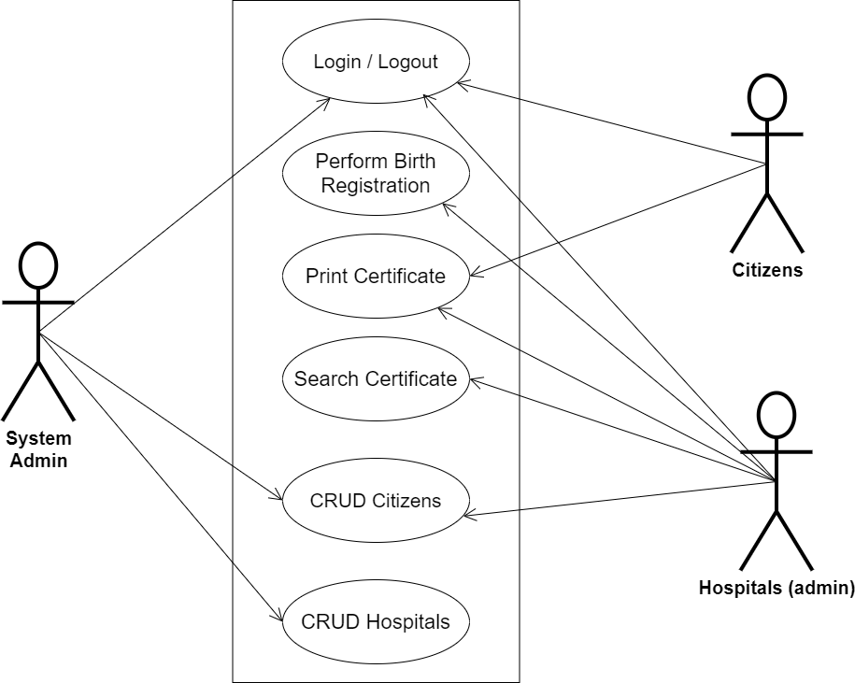

**Fig 3.1 System Use Case Diagram**

**3.3.2 Class Diagrams**

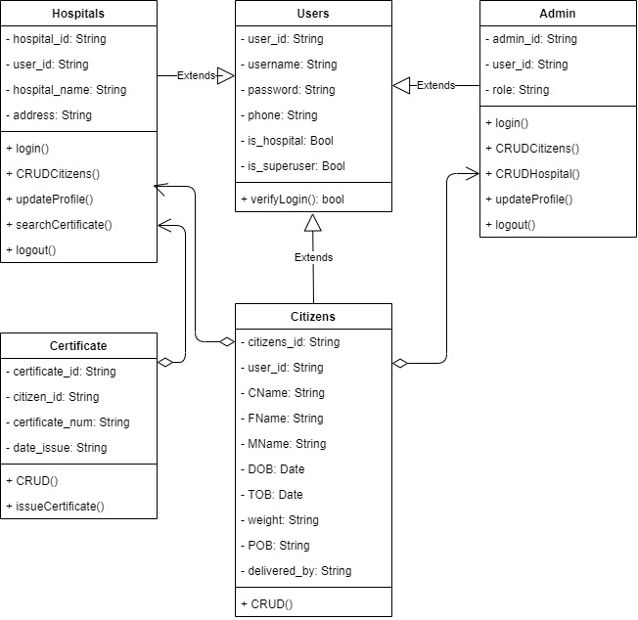

**Fig 3.2 System Class Diagram**

**3.3.3 Activity Diagrams**

**Login**

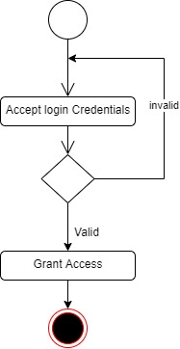The process for gaining access to the system is depicted in the diagram below; the email address and password must be accurate to gain access.

**Fig 3.3 System Login Activity Diagram**

**Register Citizens**

The process for registering citizens for birth certificate issuance is depicted in the diagram below; The system ensures that the user is authenticated using their registered email and password before they can be authorized to perform the registration.

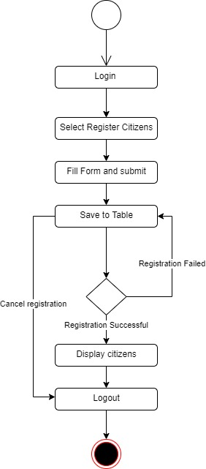

**Fig 3.4 Register Citizens Activity Diagram**

**Registering Hospitals**

The process for registering hospitals is depicted in the diagram below; The system ensures that the user is authenticated and authorized to perform the registration for validity purposes.

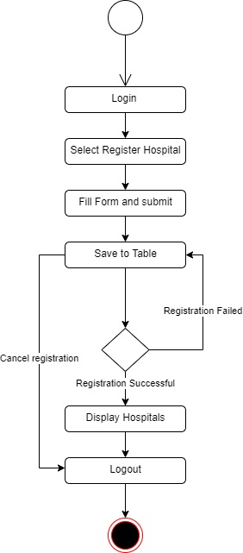

**Fig 3.5 Hospital Registration Activity Diagram**

**3.4 Database Design**

The following are some of the input specifications used in this project work.

1. Users Table: contains the generic information of all system users.
2. Citizens Table: contains every system registered citizen’s information.

**Table 3.1 Users Input Specification Table**

|  |  |  |  |  |  |
| --- | --- | --- | --- | --- | --- |
| **Field Name** | **Data Type** | **Null** | **Key** | **Length** | **Description** |
| user_id | Varchar | No | PK | 32 | Unique string for identifying users |
| username | Varchar | No |  | 20 | Unique name for users |
| password | Varchar | No |  | 128 | User Password |
| phone | Varchar | No |  | 11 | User phone number |
| pics | Varchar | No |  | 100 | User profile picture |
| is_hospital | Varchar | No |  | 5 | Boolean to verify if a user is of hospital_type |
| is_superuser | Varchar | No |  | 5 | Boolean to verify if a user is an administrator |

**Table 3.2 Citizen Input Specification Table**

|  |  |  |  |  |  |
| --- | --- | --- | --- | --- | --- |
| **Field Name** | **Data Type** | **Null** | **Key** | **Length** | **Description** |
| citizens_id | Varchar | No | PK | 32 | Unique string for identifying citizens |
| user_id | BigInt | No |  | - | Reference to the User table |
| CName | Varchar | No |  | 60 | Citizen full name |
| FName | Varchar | No |  | 60 | Citizen father name |
| MName | Varchar | No |  | 60 | Citizen mother name |
| DOB | Date | No |  | 20 | Citizen’s Date of birth |
| TOB | Date | No |  | 20 | Citizen Time of birth |
| weight | Double | No |  | 10 | Citizen weight at birth |
| POB | Varchar | No |  | 60 | Citizen’s place of birth |
| delivered_by | String | No |  | 60 | The hospital that made the registration |

**3.5 Output Design**

This declares and displays the outcome of the given input. This system's output is dependent on its input. The output specification is listed below.

**Table 3.3 Users output design table**

**CENTRAL e-BIRTH MANAGEMENT SYSTEM**

**List of the System Registered Users**

|  |  |  |  |  |  |
| --- | --- | --- | --- | --- | --- |
| **User_id** | **Username** | **Phone** | **Phone** | **Is_hospital** | **Is_superuser** |
| XXXX | XXXX | XXXX | XXXX | XXXX | XXXX |
| XXXX | XXXX | XXXX | XXXX | XXXX | XXXX |
| XXXX | XXXX | XXXX | XXXX | XXXX | XXXX |
| XXXX | XXXX | XXXX | XXXX | XXXX | XXXX |

**Table 3.4 Allocation output design table**

**CENTRAL e-BIRTH MANAGEMENT SYSTEM**

**List of the System Registered Citizens**

|  |  |  |  |  |  |  |  |  |  |
| --- | --- | --- | --- | --- | --- | --- | --- | --- | --- |
| **citizens_id** | **user_id** | **CName** | **FName** | **MName** | **DOB** | **TOB** | **Weight** | **POB** | **Delivered_by** |
| XXXX | XXXX | XXXX | XXXX | XXXX | XXX | XX | XXXX | XXXX | XXXX |
| XXXX | XXXX | XXXX | XXXX | XXXX | XXX | XX | XXXX | XXXX | XXXX |
| XXXX | XXXX | XXXX | XXXX | XXXX | XXX | XX | XXXX | XXXX | XXXX |
| XXXX | XXXX | XXXX | XXXX | XXXX | XXX | XX | XXXX | XXXX | XXXX |

**3.6 Input & User Interface Design**

This is a graphic depiction of the system interface; it will be designed to be user-friendly, responsive, and visually beautiful. Furthermore, it will be appropriately safeguarded, thus authorization will be required to see certain levels of the information. To help with the designs, a mid-fidelity wireframing program called Draw.io is employed.

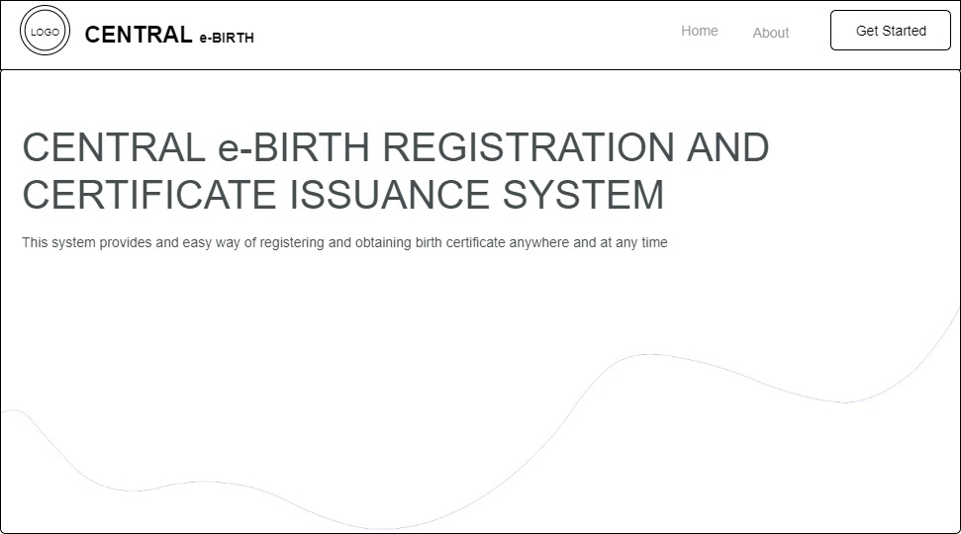

**Fig 3.6 Home Page**

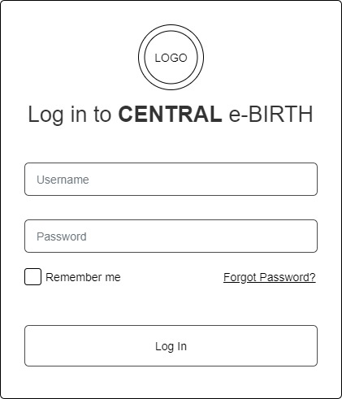

**Fig 3.7 Login Form**

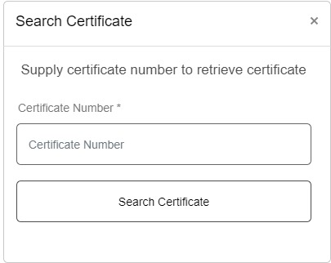

**Fig 3.8 Search Certificate**

**3.7 System Requirement**

Every software system built has a stated system requirement on which it is meant to execute for best performance. The system requirements, on the other hand, are the bare minimum of hardware and software required for the system to work properly.

**3.7.1 Hardware Requirement**

System Hardware Requirement Include:

1. Minimum of 2 GB of RAM (Random Access Memory).
2. Minimum of Intel Dual core processor.
3. Minimum of 250GB HDD (Hard Disk Drive).

**3.7.2 Software Requirement**

The software requirements include:

1. At least windows 7 OS (Operating System).
2. Vs. Code IDE installation.
3. Browsers include Chrome and Firefox.

**3.8 Choice of Programming Language**

This research project will be a web-based application built on a relational database architecture (SQLite). For frontend development, HTML (hypertext markup language), CSS (cascading style sheet), and JavaScript will be used, while Django (Python) will be used for backend programming.

**CHAPTER FOUR**

# SYSTEM IMPLEMENTATION EVALUATION

# 4.1 Introduction

This section describes in concise detail how the new system is implemented for effective operation. It shows samples of the working (new) system designed and how the system is to be installed.

# System Testing and Evaluation

There are several reasons to test the produced system. For example, only via testing will we be able to assess any faults in the new system and propose answers to these problems. This project used both unit and integration testing to confirm the efficacy and efficiency of the design, as well as to ensure the new system satisfies its functional requirements and is error-free.

**Unit Testing**

This part examines specific units or single components of the system individually to confirm that specific phases function properly and without problems.

**Integration Testing**

The software was tested utilizing integration testing, in which all parts were assembled and functioned as one. The connectivity between the various components was checked to ensure they are properly integrated and the units can work together.

# 4.3 System Installation

In order to use the proposed application on any computer system, the following steps need to be taken:

1. Make sure, pip, pipenv, and python3 or greater are installed on the system.
2. Copy your project folder to any location of your choice.
3. Open project folder in Visual Studio Code
4. On the terminal run “pipenv install -r requirements.txt”
5. On the terminal run “python manage.py runserver”
6. Open any browser on the system example Chrome, Microsoft Edge, Mozilla Firefox.
7. On the address bar, type <http://127.0.0.1> and press the enter key the site should be loaded.

# 4.4 Security Measures

Since the scope of the application is public, literally all the information is made available to any user, but some functionalities are restricted to the hospital admin and functionalities that have to do with updating the hospital profile, creating hospital staff, handling birth registrations, etc. The restriction is carried out by using passwords when the hospital admin webpage is accessed. Notwithstanding some functionalities are also restricted to the specific type of user.

# 4.5 Sample Outputs

These describe and give the pictorial representation of the program or software; it shows and gives a clear understanding of the design, and displays all the interfaces.

**Homepage**

This depicts the homepage which is the introductory page of the website. It is the first page that users typically see when they visit a website's domain or click on its link. The purpose of this page is to provide an overview of the website's content, and features.

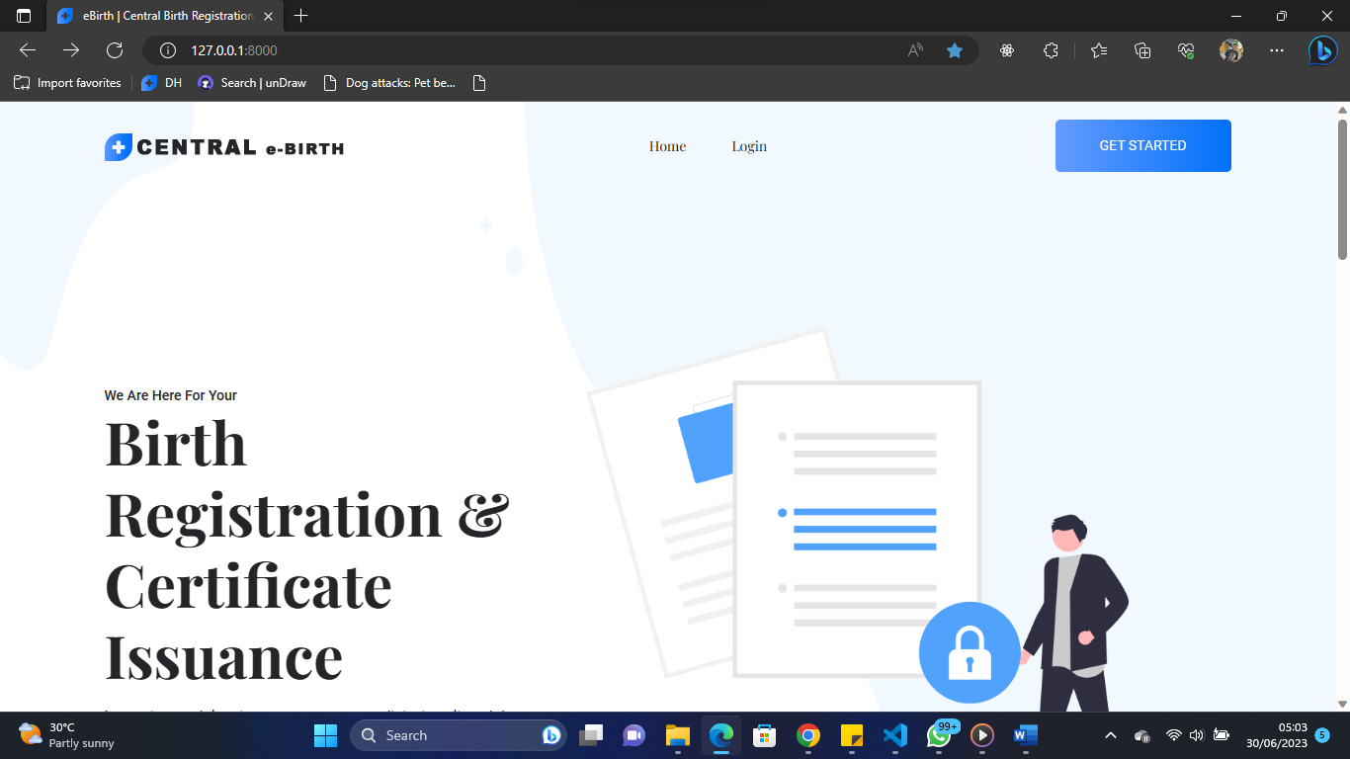

Fig 4.1 Homepage

**User Login**

This is a page that grants users (hospital admin, hospital staff, and registered citizens) access to the system only if the correct credentials are provided.

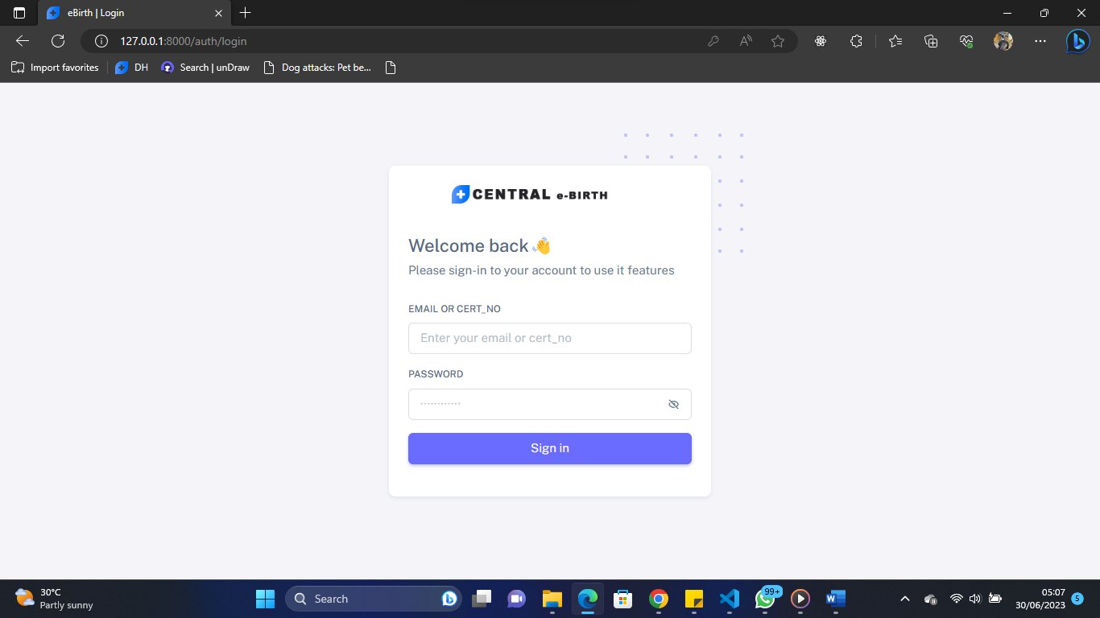

Fig 4.2 User Login

**System Admin Login**

This is a page that grants the superuser which is the system admin access to the system only if the correct credentials are provided.

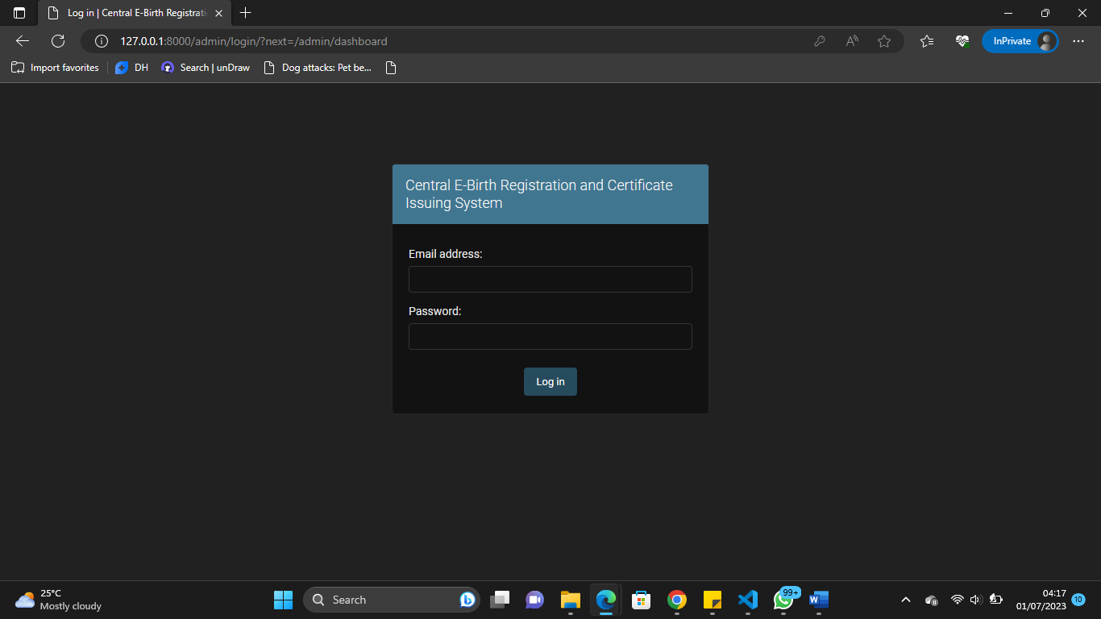

Fig 4.3 System Admin Login

**Hospital Admin Dashboard**

This is the hospital admin dashboard, the sidebar shows the available functionality for the user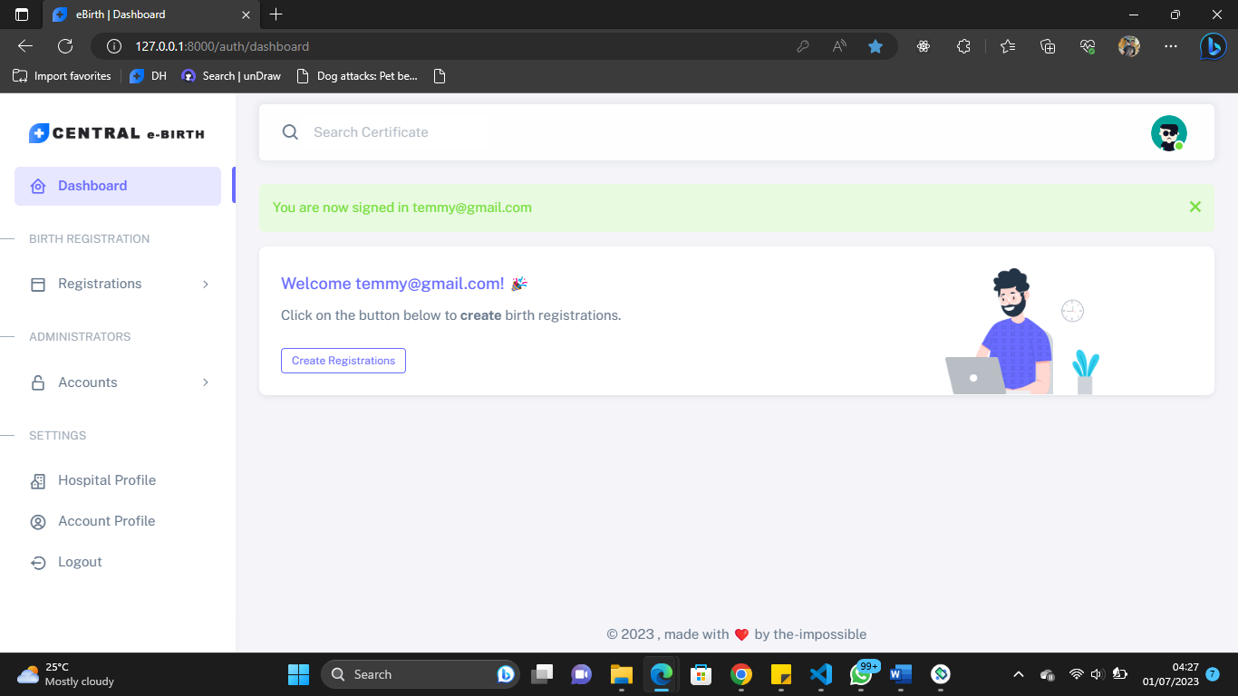

Fig 4.4 Hospital Admin Dashboard

**Hospital Staff Dashboard**

This is the hospital staff dashboard, the sidebar shows the available functionality for the user

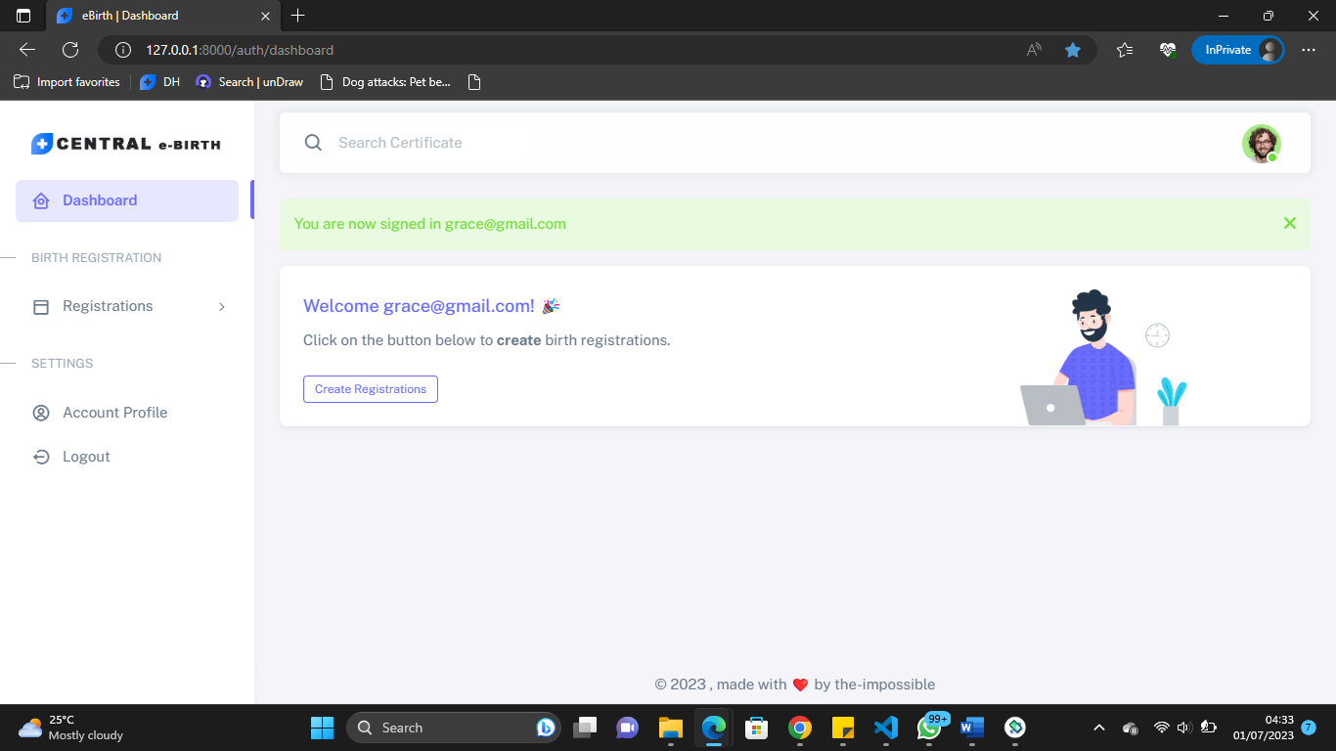

Fig 4.5 Hospital Staff Dashboard

**Citizen’s Dashboard**

This is the citizen’s dashboard, the sidebar shows the available functionality for the user

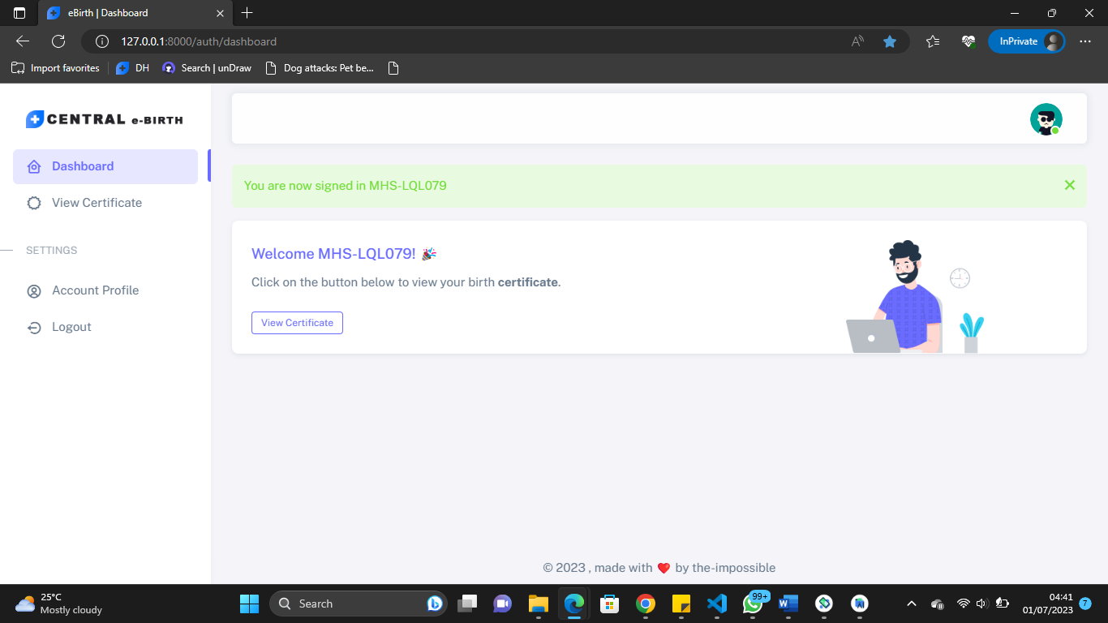

Fig 4.6 Citizen’s Dashboard

**Birth Registration Page**

This is the page where hospital admin or staff can perform birth registrations for citizens

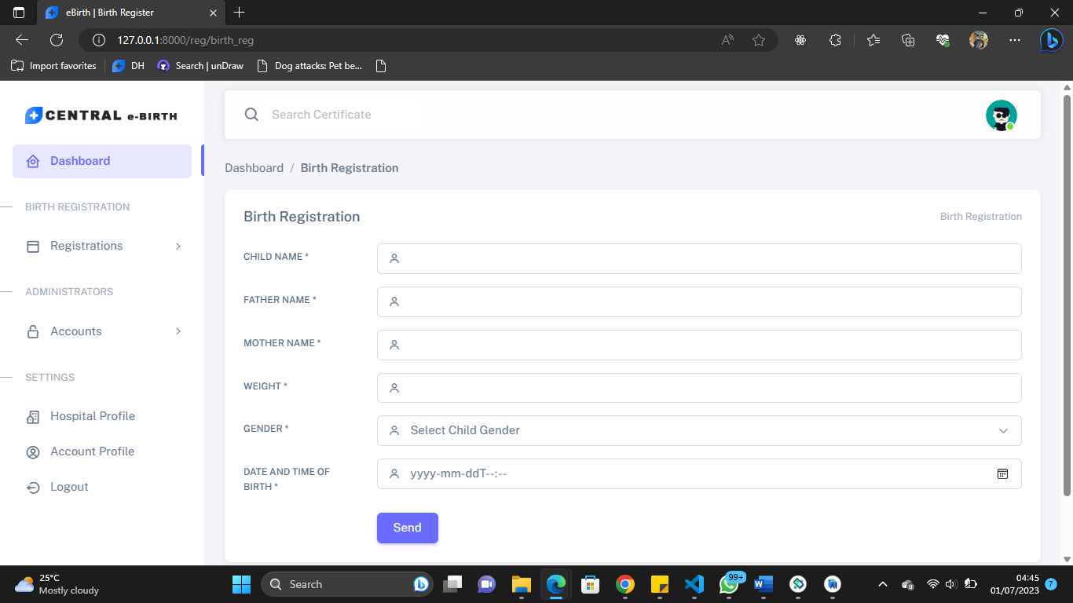

Fig 4.7 Birth Registration Page

**Manage Registration Page**

This page contains all registered birth certificates where the hospital admin and staff can make changes to them if need be

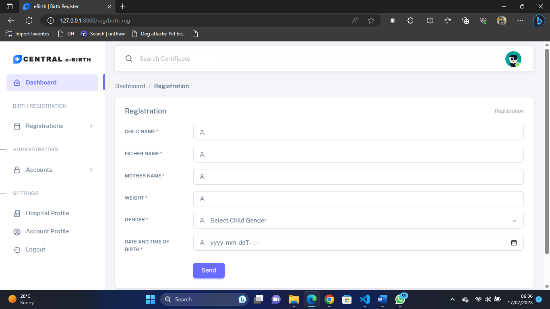

Fig 4.8 Manage Registration Page

**Create a Hospital Staff Page**

This page is used by the hospital admin to create a hospital staff account

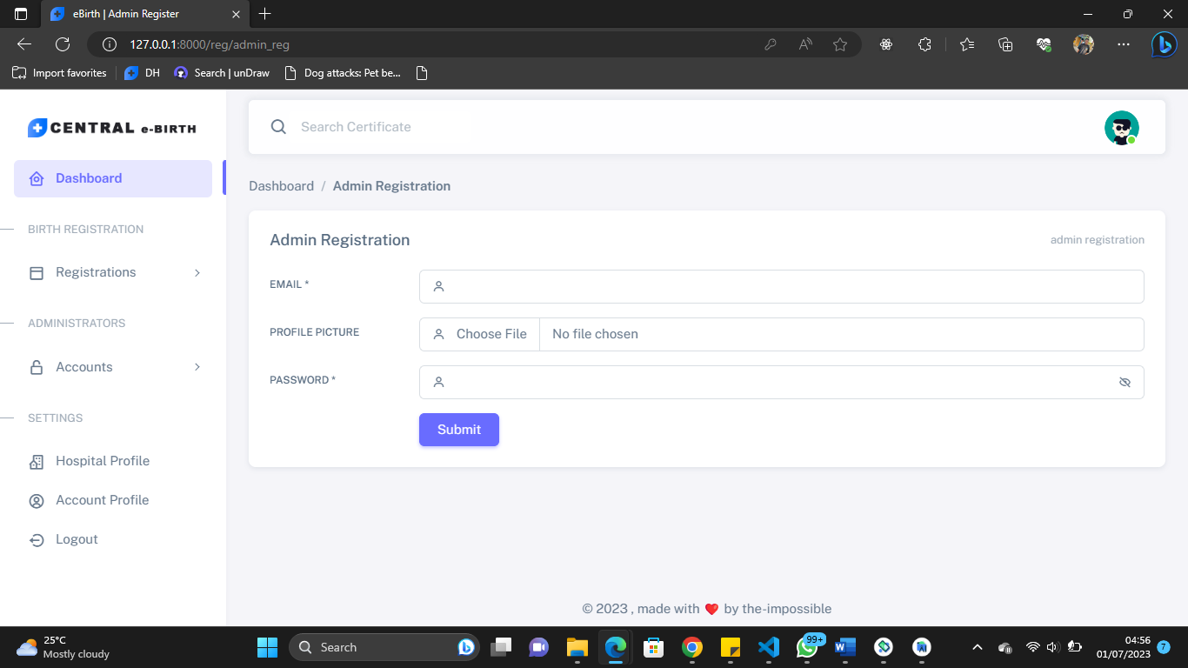

Fig 4.9 Create Hospital Staff Page

**Manage Hospital Staff**

This page contains staff registered under the hospital and the hospital admin can make changes to them if need be

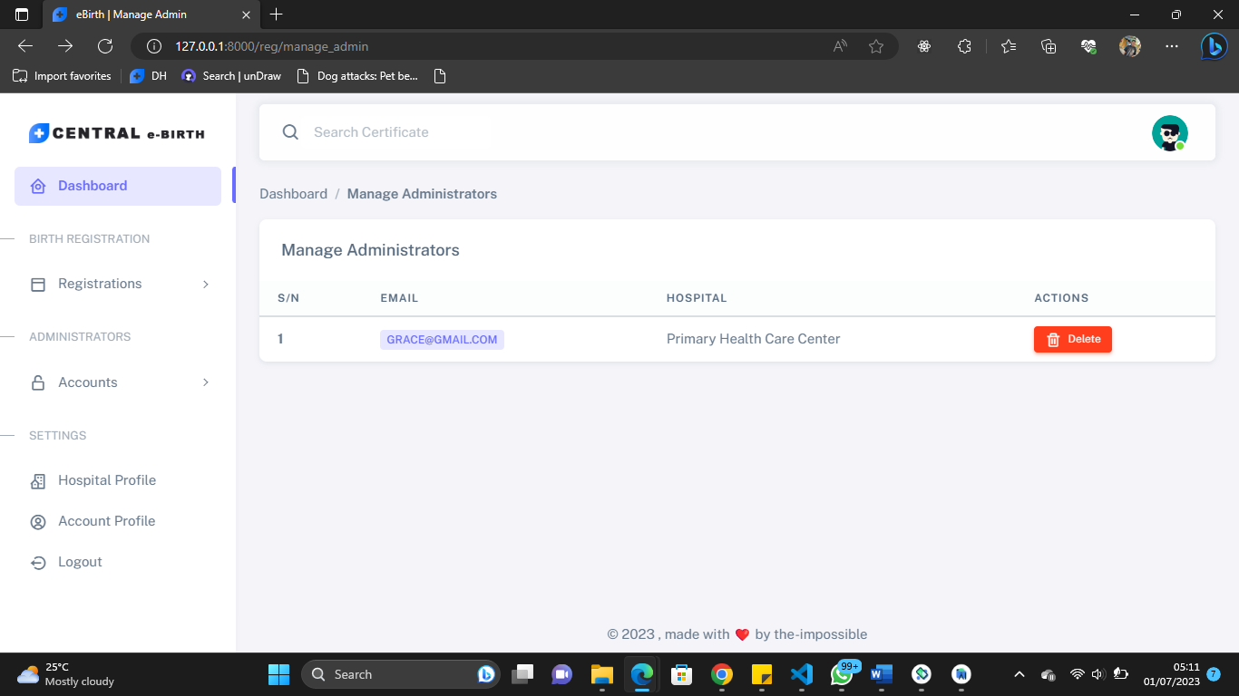

Fig 4.10 Manage Hospital Staff

**Hospital Profile**

This page displays the hospital profile, and the hospital admin can perform updates on it

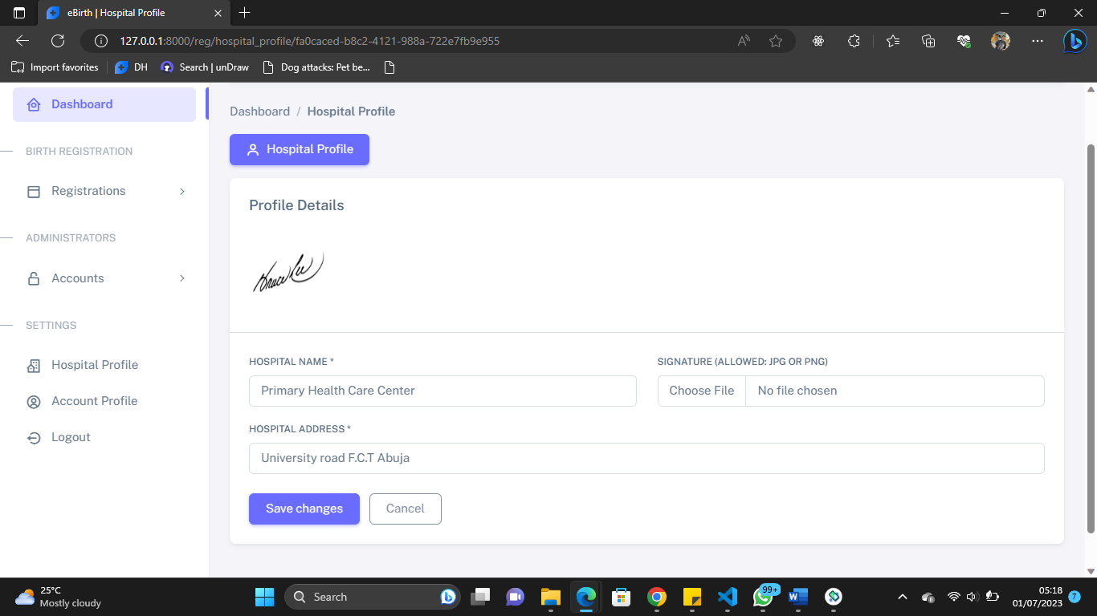

Fig 4.11 Hospital Profile

**Account Profile**

This page performs updates on their profile for every authenticated user

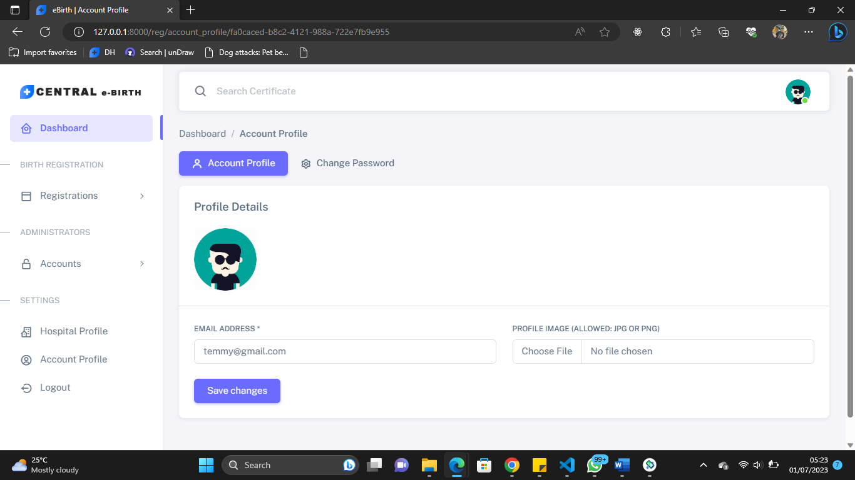

Fig 4.12 Account Profile

**Change Password**

Authenticated users can use this page to change their account password

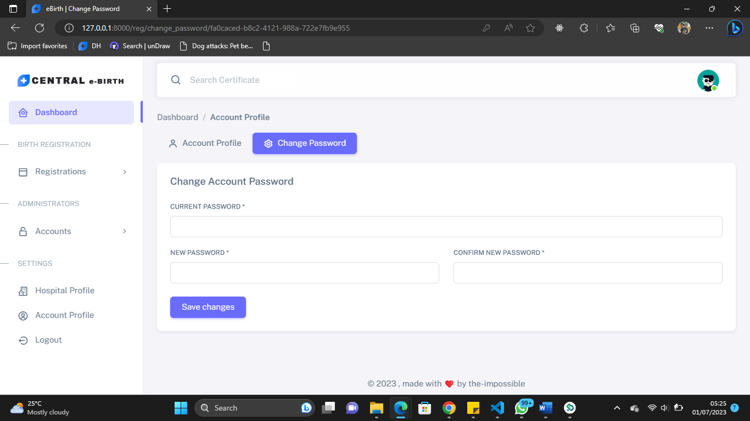

Fig 4.13 Change Password

**View Birth Certificate**

Authenticated citizens can view their birth certificate and print it at anytime.

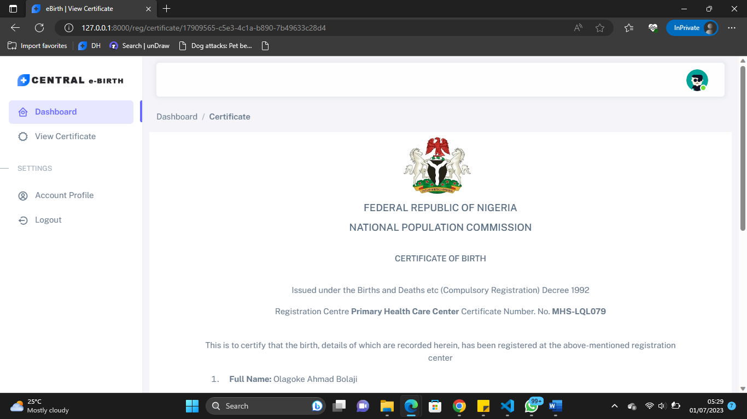

Fig 4.14 View Birth Certificate

**Print Birth Certificate**

Print functionality is embedded in the system so that citizens can click to print the certificate

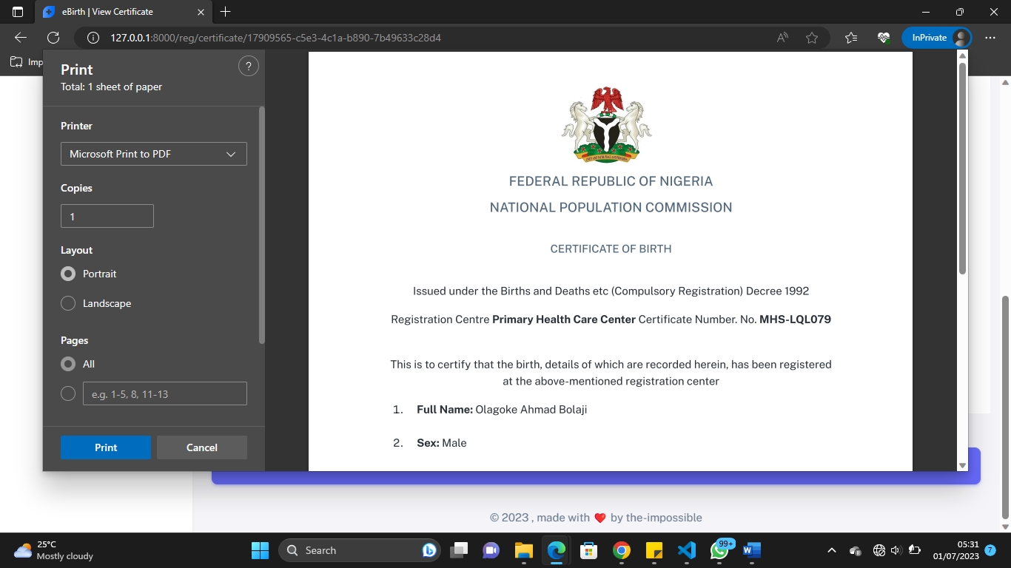

Fig 4.15 Print Birth Certificate

**Search Birth Certificate**

Search functionality is embedded in the system so that hospital admin and staff can quickly search for certificates by entering the certificate number, name of child etc.

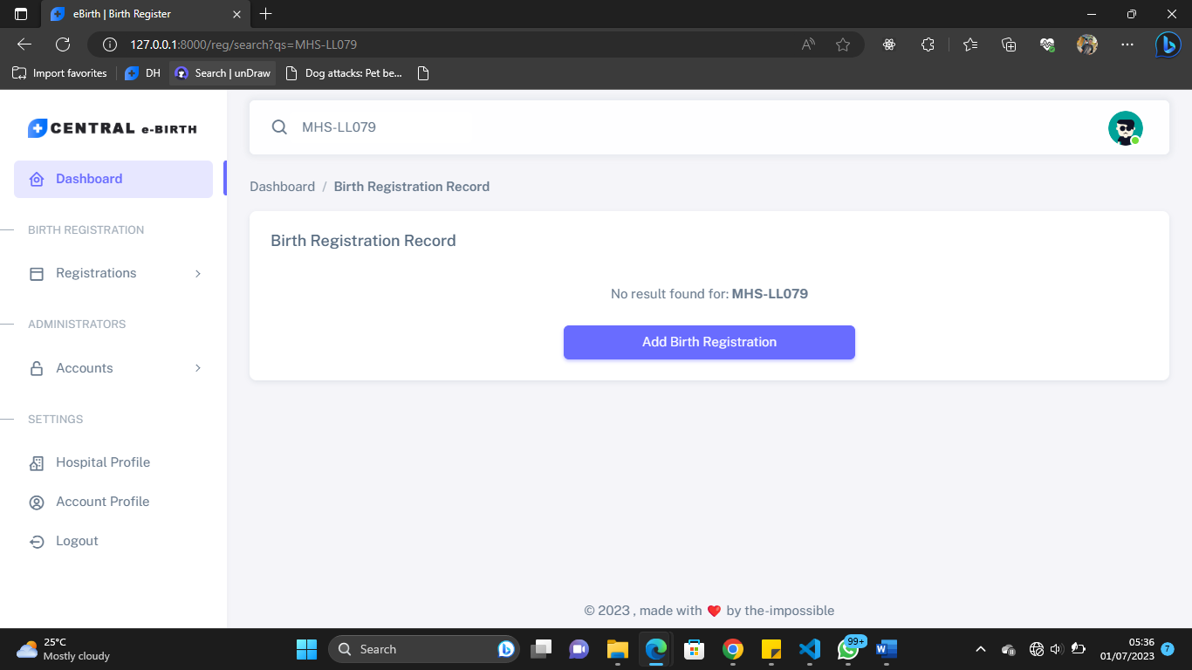

Fig 4.16 Search Birth Certificate

**System Admin Dashboard**

This is the system admin dashboard, the admin can oversee and manage the entire operations perform by other system users (hospital admin, hospital staff, and citizen’s)

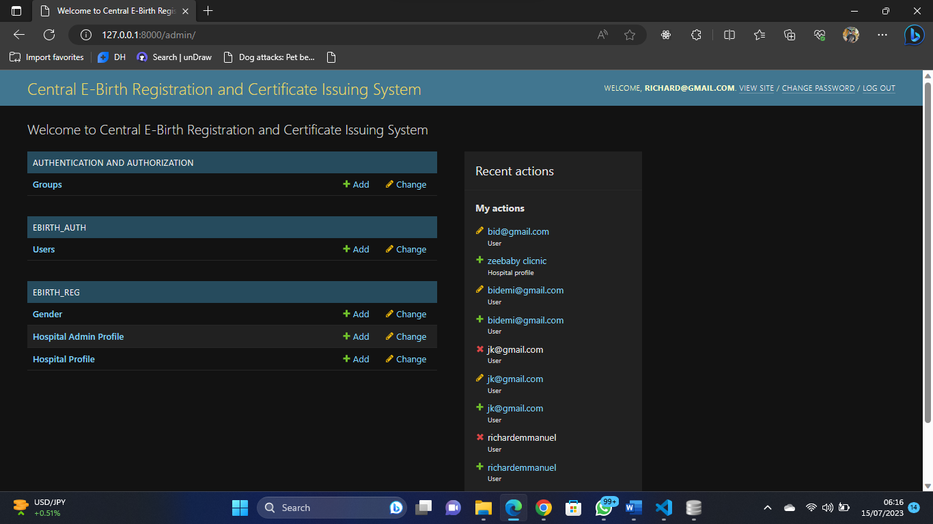

Fig 4.17 System Admin Dashboard

**CHAPTER FIVE**

# SUMMARY CONCLUSION AND RECOMMENDATION

# 5.1 Summary

This research project aims to develop a Central E-Birth Registration and Certificate Issuing System to overcome the limitations of manual birth registration processes. Manual registration methods are prone to errors and can lead to inaccurate records and inefficient population statistics. The proposed Central E-Birth Registration and Certificate Issuing System offers a globally accessible system that streamlines the registration process, reduces costs, and ensures accurate record-keeping for future reference. The system will provide a user-friendly application for easy registration and printing of birth certificates. Additionally, it will enable quick certificate verification without the need for physical visits. The study focuses on the registration of newly born babies and seeks to provide an efficient and accessible solution for individuals to obtain their birth certificates. By leveraging technology, this project contributes to improving government services and facilitating the fundamental right to birth registration.

**5.2 Conclusion**

In conclusion, the research project has successfully achieved its objectives and made significant advancements by offering a user-friendly application for easy registration and printing of birth certificates, along with a streamlined process for quick certificate verification. The proposed system ensures global accessibility, reduces costs, and enables accurate record-keeping for future reference. It contributes to the fulfillment of children's rights to birth registration and supports efficient social service planning by governments. However, further testing, refinement, and collaboration with relevant stakeholders are necessary to ensure the effectiveness and successful implementation of the Central E-Birth Registration and Certificate Issuing System. With these efforts, the system has the potential to improve the birth registration process, enhance data accuracy, and provide individuals with an easy and accessible way to obtain their birth certificates.

# 5.2 Recommendation

Based on the research and development of the Central E-Birth Registration and Certificate Issuing System, the following recommendations are suggested:

1. Government Adoption: It is recommended that government authorities and relevant agencies consider adopting the Central E-Birth Registration and Certificate Issuing System. This system offers significant advantages over the manual registration process, including improved accuracy, accessibility, and efficiency in managing birth records.
2. Integration with Existing Systems: The Central E-Birth Registration and Certificate Issuing System should be integrated with existing government databases and civil registration systems. This integration will facilitate data sharing and ensure seamless coordination between various government departments.
3. Data Security and Privacy Measures: As the system will handle sensitive personal information, it is crucial to implement robust data security and privacy measures. Employing encryption, access controls, and regular security audits will help safeguard the data and protect individual privacy.
4. Scaling and Expansion: Once successfully implemented, the system can be scaled up and expanded to cover birth registration for adults and other vital records, such as marriage and death certificates. This expansion will further streamline administrative processes and enhance overall government services.

By considering these recommendations, the Central E-Birth Registration and Certificate Issuing System can become a transformative tool in ensuring accurate and accessible birth registration for all children, thereby protecting their rights and facilitating efficient government planning and service delivery.

**REFERENCES**

Arumugam, V., Singh, P., Padhiyar, K., Manek, R., & Sayyad, S. (2021). Academic Project

Information Management System. *Institute of Electrical and Electronics Engineers Inc*. https://doi.org/10.1109/ASIANCON51346.2021.9544565

Khandagale,S., Dherange, H., Nawale, S. (2022). Web Base Online Birth Registration and

Certification System*. International Journal of Research Publication and Reviews3*(12), pp 676-679

Ojokoh, Bolanle &Afolayan, Abimbola. (2017). E-birth registration and certificate issuance

System: Federal University of Technology, Akure, Department of Computer Science,

Oshomoh, H.M. (2017). Design and implementation of an online national database for birth and death registration (a case study of the national population commission, Benin city). Western Delta University, Oghara, Delta State, Nigeria, Department of Mathematics and Computer Science

Pelumi, A. (2016). Development of a Web Application for Birth and Death Certificate Request:

University of Ibadan, Ibadan Nigeria, Department of Computer Science.

Sonali S.C., (2021). Online Birth Registration & Certification System. *International Research*

*Journal of Engineering and Technology (IRJET). 8*(7) e-ISSN: 2395-0056

**APPENDIX**

Views.py

from django.shortcuts import render, redirect

from django.views import View

from django.views.generic.base import TemplateView

from django.contrib.auth import authenticate, login, logout

from django.contrib import messages

from django.contrib.auth import get_user_model

from django.contrib.auth.mixins import LoginRequiredMixin

# My app imports

# Create your views here.

class DashboardView(LoginRequiredMixin, TemplateView):

    template_name = "auth/dashboard.html"

class LoginView(View):

    def get(self, request):

        return render(request, 'auth/login.html')

    def post(self, request):

        username = request.POST.get('username').strip()

        password = request.POST.get('password').strip()

        if username and password:

            user = authenticate(request, username=username, password=password)

            if user:

                if user.is_active:

                    login(request, user)

                    messages.success(request, f"You are now signed in {user}")

                    nxt  = request.GET.get('next', None)

                    if nxt is None:

                        return redirect('auth:dashboard')

                    return redirect(self.request.GET.get('next', None))

                else:

                    messages.warning(request, 'Account not active contact the administrator')

            else:

                messages.error(request, 'Invalid login credentials')

        else:

            messages.error(request, 'All fields are required!!')

        return redirect('auth:login')

class LogoutView(LoginRequiredMixin, View):

    def post(self, request):

        logout(request)

        messages.success(request, 'You are successfully logged out, to continue login again')

        return redirect('auth:login')

**Homepage**

{% extends 'base.html' %}

{% load static %}

{% block title %}Central Birth Registration and Certificate Issuing System{% endblock title %}

{% block head %}{% include 'partials/head.html' %}{% endblock head %}

{% block body %}

    {% block nav %} {% include 'partials/nav.html' %} {% endblock %}

    <!-- banner part start-->

    <section class="banner_part">

        <div class="container">

            <div class="row align-items-center">

                <div class="col-lg-5 col-xl-5">

                    <div class="banner_text">

                        <div class="banner_text_iner">

                            <h5>We are here for your</h5>

                            <h1>Birth Registration & Certificate Issuance</h1>

                            <p>Lorem ipsum dolor sit amet, consectetur adipiscing

                                elit sed do eiusmod tempor incididunt ut labore et dolore

                                magna aliqua. Quis ipsum suspendisse ultrices gravida.Risus cmodo viverra </p>

                            <a href="{% url 'auth:login' %}" class="btn_2">Get Started</a>

                        </div>

                    </div>

                </div>

                <div class="col-lg-7">

                    <div class="banner_img">

                        <img src="{% static 'img/banner_img.png' %}" alt="">

                    </div>

                </div>

            </div>

        </div>

    </section>

    <!-- banner part start-->

    <!-- about us part start-->

    <section class="about_us padding_top">

        <div class="container">

            <div class="row justify-content-between align-items-center">

                <div class="col-md-6 col-lg-6">

                    <div class="about_us_img">

                        <img src="{% static 'img/top_service.png' %}" alt="">

                    </div>

                </div>

                <div class="col-md-6 col-lg-5">

                    <div class="about_us_text">

                        <h2>About us</h2>

                        <p>Lorem ipsum dolor sit amet, consectetur adipiscing elit sed

                            do eiusmod tempor incididunt ut labore et dolore magna aliqua

                            Quis ipsum suspendisse ultrices gravida. Risus cmodo viverra

                            maecenas accumsan lacus vel</p>

                        <a class="btn_2 " href="#">learn more</a>

                        <div class="banner_item">

                            <div class="single_item">

                                <img src="{% static 'img/icon/banner_1.svg' %}" alt="">

                                <h5>Registration</h5>

                            </div>

                            <div class="single_item">

                                <img src="{% static 'img/icon/banner_2.svg' %}" alt="">

                                <h5>Certificate</h5>

                            </div>

                            <div class="single_item">

                                <img src="{% static 'img/icon/banner_3.svg' %}" alt="">

                                <h5>Centralization</h5>

                            </div>

                        </div>

                    </div>

                </div>

            </div>

        </div>

    </section>

    <!-- about us part end-->

    <!-- feature_part start-->

    <section class="feature_part">

        <div class="container">

            <div class="row justify-content-center">

                <div class="col-xl-8">

                    <div class="section_tittle text-center">

                        <h2>Our services</h2>

                    </div>

                </div>

            </div>

            <div class="row justify-content-between align-items-center">

                <div class="col-lg-3 col-sm-12">

                    <div class="single_feature">

                        <div class="single_feature_part">

                            <span class="single_feature_icon"><img src="{% static 'img/icon/feature_1.svg' %}" alt=""></span>

                            <h4>Better Registration</h4>

                            <p class="text-justify">Lorem ipsum dolor sit amet, consectetur adipiscing elit sed do eiusmod tempor incididunt ut labore et dolore magna aliqua.</p>

                        </div>

                    </div>

                    <div class="single_feature">

                        <div class="single_feature_part">

                            <span class="single_feature_icon"><img src="{% static 'img/icon/feature_2.svg' %}" alt=""></span>

                            <h4>Certificate Issuance</h4>

                            <p class="text-justify">Lorem ipsum dolor sit amet, consectetur adipiscing elit sed do eiusmod tempor incididunt ut labore et dolore magna aliqua.</p>

                        </div>

                    </div>

                </div>

                <div class="col-lg-4 col-sm-12">

                        <div class="single_feature_img">

                            <img src="{% static 'img/service.png' %}" alt="">

                        </div>

                </div>

                    <div class="single_feature">

                        <div class="single_feature_part">

                            <span class="single_feature_icon"><img src="{% static 'img/icon/feature_2.svg' %}" alt=""></span>

                            <h4>Better Security</h4>

                            <p class="text-justify">Lorem ipsum dolor sit amet, consectetur adipiscing elit sed do eiusmod tempor incididunt ut labore et dolore magna aliqua.</p>

                        </div>

                    </div>

                </div>

            </div>

        </div>

    </section>

    <!-- feature_part start-->

    {% block footer %}{% include 'partials/footer.html' %}{% endblock footer %}

    {% block script %}{% include 'partials/script.html' %}{% endblock script %}

{% endblock body %}